# Project Change Request Form

# Change Request Information

|  |  |  |  |
| --- | --- | --- | --- |
| **Project** | TUV Limited | **Change title** | **Website Update** |
| **Initiated by** | Mr. Ahmed | **Priority (L,M,H)** | High |
| **Date** | 25/5/2025 | **Change number** | 1 |

# Change Request Details

|  |
| --- |
| **Description** |
| Remove find Certificate button website |

|  |
| --- |
| **Justification** |
| Stake Holder Request |

# Details

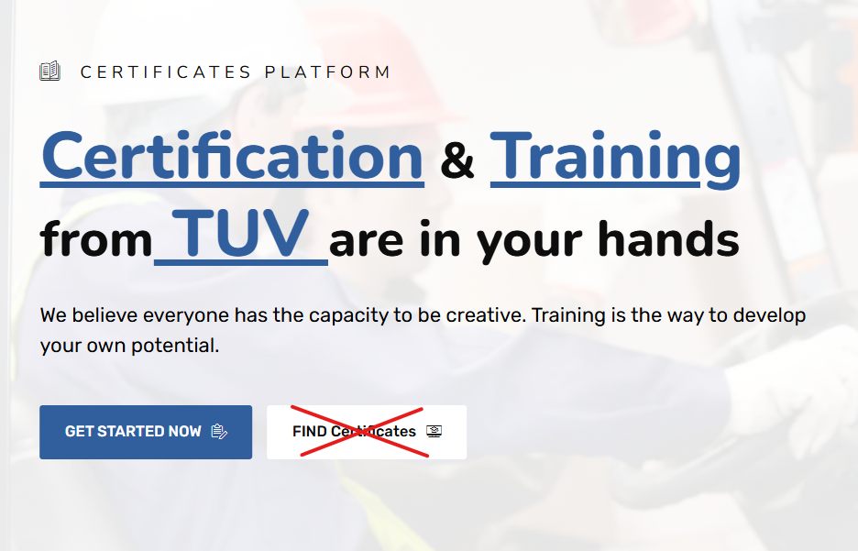

# Management Approval

|  |  |  |  |  |  |
| --- | --- | --- | --- | --- | --- |
| **Approval date** |  | **Name** |  | **Decision** | Accepted  Rejected |

|  |  |
| --- | --- |
| **Comments** |  |

# Change Request Information

|  |  |  |  |
| --- | --- | --- | --- |
| **Project** | TUV Limited | **Change title** | **Website Update** |
| **Initiated by** | Mr. Ahmed | **Priority (L,M,H)** | High |
| **Date** | 25/5/2025 | **Change number** | 2 |

# Change Request Details

|  |
| --- |
| **Description** |
| **We will remove the (Certificates) sections from the home page and put them in our service section in (Certificate and Auditing).**  **1- When the user clicks on (certificate and auditing)**  **2- Show him the (Certificates) sections.** |

|  |
| --- |
| **Justification** |
| Stake Holder Request |

# Details

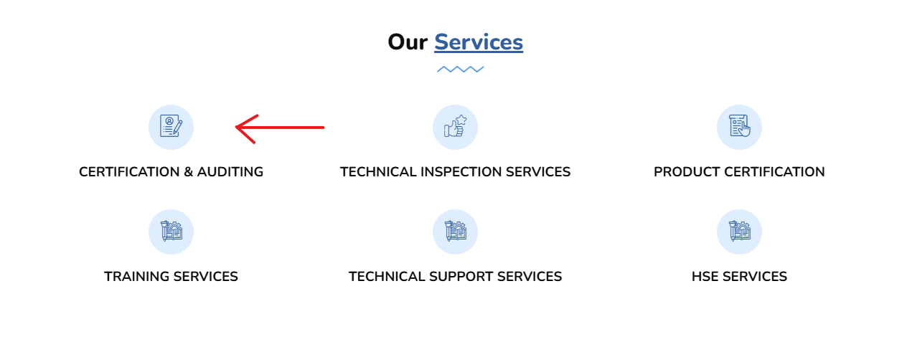

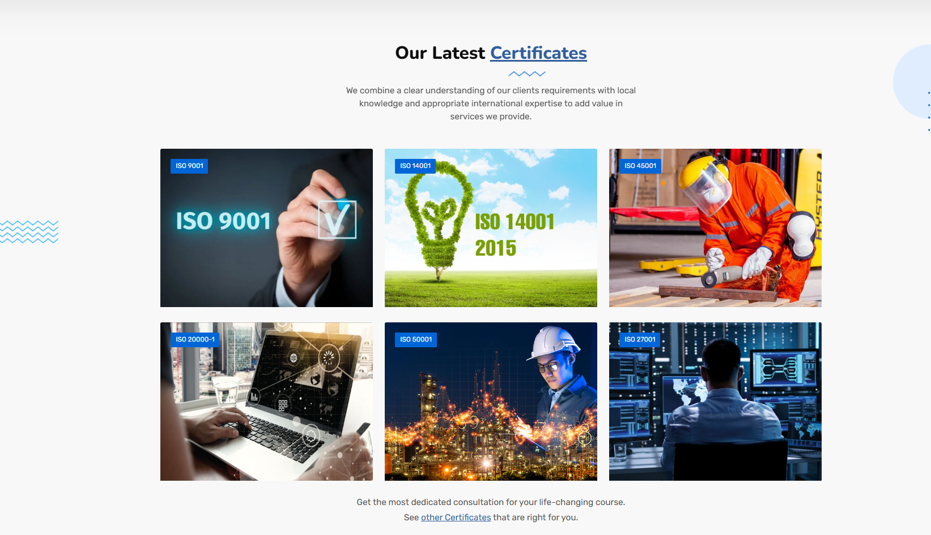

# Management Approval

|  |  |  |  |  |  |
| --- | --- | --- | --- | --- | --- |
| **Approval date** |  | **Name** |  | **Decision** | Accepted  Rejected |

|  |  |
| --- | --- |
| **Comments** |  |

# Change Request Information

|  |  |  |  |
| --- | --- | --- | --- |
| **Project** | TUV Limited | **Change title** | **Website Update** |
| **Initiated by** | Mr. Ahmed | **Priority (L,M,H)** | High |
| **Date** | 25/5/2025 | **Change number** | 3 |

# Change Request Details

|  |
| --- |
| **Description** |
| **We will add a ( Process diagram ) its shows once user clicks on (Get started now)** |

|  |
| --- |
| **Justification** |
| Stake Holder Request |

# Details



# Management Approval

|  |  |  |  |  |  |
| --- | --- | --- | --- | --- | --- |
| **Approval date** |  | **Name** |  | **Decision** | Accepted  Rejected |

|  |  |
| --- | --- |
| **Comments** |  |

# Change Request Information

|  |  |  |  |
| --- | --- | --- | --- |
| **Project** | TUV Limited | **Change title** | **Website Update** |
| **Initiated by** | Mr. Ahmed | **Priority (L,M,H)** | High |
| **Date** | 25/5/2025 | **Change number** | 4 |

# Change Request Details

|  |
| --- |
| **Description** |
| **We will make a dynamic function for the (About Us) section to help admin users add the content what they want in these sections at any time.** |

|  |
| --- |
| **Justification** |
| Stake Holder Request |

# Details



# Management Approval

|  |  |  |  |  |  |
| --- | --- | --- | --- | --- | --- |
| **Approval date** |  | **Name** |  | **Decision** | Accepted  Rejected |

|  |  |
| --- | --- |
| **Comments** |  |

# Change Request Information

|  |  |  |  |
| --- | --- | --- | --- |
| **Project** | TUV Limited | **Change title** | **Website Update** |
| **Initiated by** | Mr. Ahmed | **Priority (L,M,H)** | High |
| **Date** | 25/5/2025 | **Change number** | 5 |

# Change Request Details

|  |
| --- |
| **Description** |
| **We will remove (Overview) from (Our Service)** |

|  |
| --- |
| **Justification** |
| Stake Holder Request |

# Details

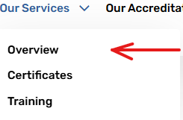

# Management Approval

|  |  |  |  |  |  |
| --- | --- | --- | --- | --- | --- |
| **Approval date** |  | **Name** |  | **Decision** | Accepted  Rejected |

|  |  |
| --- | --- |
| **Comments** |  |

# Change Request Information

|  |  |  |  |
| --- | --- | --- | --- |
| **Project** | TUV Limited | **Change title** | **Website Update** |
| **Initiated by** | Mr. Ahmed | **Priority (L,M,H)** | High |
| **Date** | 7/5/2025 | **Change number** | 6 |

# Change Request Details

|  |
| --- |
| **Description** |
| **We will make a dynamic function for the (Our location) section to help admin users add the content what they want in these sections at any time.** |

|  |
| --- |
| **Justification** |
| Stake Holder Request |

# Details

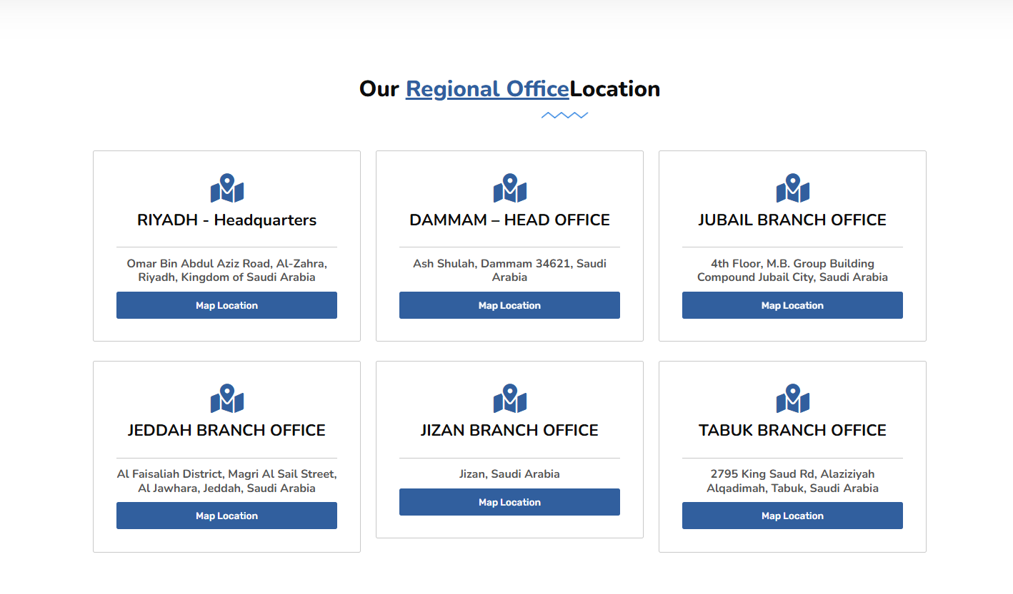

# Management Approval

|  |  |  |  |  |  |
| --- | --- | --- | --- | --- | --- |
| **Approval date** |  | **Name** |  | **Decision** | Accepted  Rejected |

|  |  |
| --- | --- |
| **Comments** |  |

# Change Request Information

|  |  |  |  |
| --- | --- | --- | --- |
| **Project** | TUV Limited | **Change title** | **Website Update** |
| **Initiated by** | Mr. Ahmed | **Priority (L,M,H)** | High |
| **Date** | 25/5/2025 | **Change number** | 7 |

# Change Request Details

|  |
| --- |
| **Description** |
| **We need from this section when user leave his own contacts and message they will be auto sent to**   1. [**info@tuv.com.sa**](https://tuv.com.sa/contact/us) 2. **walid.bendhia@tuv.com.sa** |

|  |
| --- |
| **Justification** |
| Stake Holder Request |

# Details

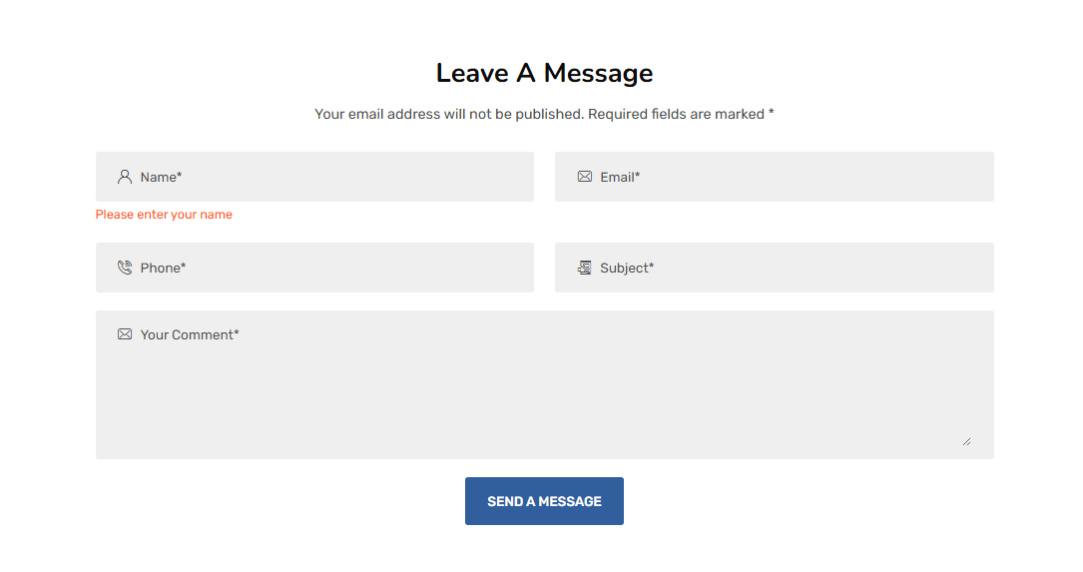

# Management Approval

|  |  |  |  |  |  |
| --- | --- | --- | --- | --- | --- |
| **Approval date** |  | **Name** |  | **Decision** | Accepted  Rejected |

|  |  |
| --- | --- |
| **Comments** |  |

# Change Request Information

|  |  |  |  |
| --- | --- | --- | --- |
| **Project** | TUV Limited | **Change title** | **Website Update** |
| **Initiated by** | Mr. Ahmed | **Priority (L,M,H)** | High |
| **Date** | 25/5/2025 | **Change number** | 10 |

# Change Request Details

|  |
| --- |
| **Description** |
| **In (Our Termes) Section We need to update (Regulation for logo use and mark) content**  **Note : Mr.Walied will send the content** |

|  |
| --- |
| **Justification** |
| Stake Holder Request |

# Details

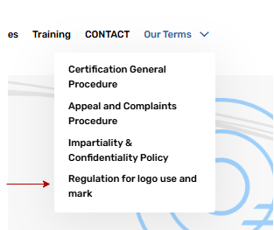

# Management Approval

|  |  |  |  |  |  |
| --- | --- | --- | --- | --- | --- |
| **Approval date** |  | **Name** |  | **Decision** | Accepted  Rejected |

|  |  |
| --- | --- |
| **Comments** |  |